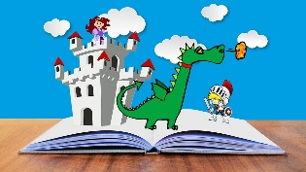**Plan your own adventure story!**

Opening

Main character:

Setting:

Build-Up

Small problem:

Climax

Something BIG happens:

How does the character solve the BIG problem?

Resolution

Happy ending or sad ending?

How has the character changed?

What did the character learn?

Ending