Name: Yung Li
Age: 10
From: Beijing, China.
Yung Li lives in an apartment with his mum, dad and younger sister. He wants to have a dog but his apartment is too small. Beijing is a very big city and has a population of 21 million people! Yung Li is lucky because he can walk to school. Yung Li loves to play computer games and he is also learning to play the violin too. His favourite food is noodles with meat. He likes living in Beijing but doesn’t like the pollution.
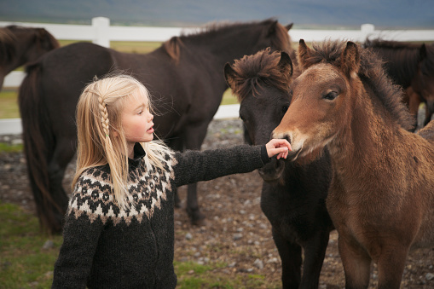
Name: Anna
Age: 11
From: Akureyri, Iceland.
Anna lives in a small city called Akureyri in Iceland. The population is only 6000 people. Anna lives with her mum and dad in a small house. She doesn’t have any brothers or sisters. Anna loves riding horses and wants to be a vet one when she grows up. She likes living in Iceland but it can be very cold and dark in winter. She thinks the best thing about where she lives is the beautiful scenery.

Name: Daniel
Age: 13
From: London, UK
Daniel lives in a town house in London with his mum, dad and two sisters. He doesn’t like sharing a room with his sister; he wants to have his own room! He loves football and supports Arsenal FC. He goes with his dad to see them play at the weekend. There are lots of things for young people to do in London and lots of parks for him to ride his bike in. His favourite food is pizza and he eats it as much as he can!
Name: Zeynep
Age: 8
From: Istanbul, Turkey.
Zeynep lives in Istanbul with her mum, dad and brother in an apartment. She has her own bedroom and likes to draw and paint in there. She is learning English and also German at school. She likes favourite thing to do in Istanbul is go the sea side with her dad and eat ice cream! She doesn’t like all the traffic in Istanbul and sometimes it can take her a long time to get to school in the morning.
Name: Andrew
Age: 12
From: The Isle of Skye, Scotland
Andrew lives on an island called Skye, in Scotland. He lives with his mum and older brother. He also has a dog called Dexter. He likes to ride his bike and go fishing with his grandad at the weekend. The island is really safe and there’s not a lot of crime so Andrew and his friends have a lot of freedom. His favourite food is Chinese food and there is one Chinese restaurant he can go to with his family on the island. He is learning how to play the bagpipes which are a traditional Scottish instrument.

Picture credits

https://pixabay.com/go/?t=image-list-getty&id=gm1129695190-298515580?utm_source=pixabay%26utm_medium=affiliate%26utm_campaign=SRP_image_sponsored%26referrer_url=https%253A//pixabay.com/images/search/chinese%252520kid/%26utm_term=chinese%2520kid

https://pixabay.com/go/?t=image-list-nohits-getty&id=gm499596900-80316071?utm_source=pixabay%26utm_medium=affiliate%26utm_campaign=SRP_image_noresults%26referrer_url=https%253A//pixabay.com/images/search/icelandic%252520kid/%26utm_term=icelandic%2520kid
https://pixabay.com/go/?t=image-list-nohits-getty&id=gm541134852-96756035?utm_source=pixabay%26utm_medium=affiliate%26utm_campaign=SRP_image_noresults%26referrer_url=https%253A//pixabay.com/images/search/12%252520year%252520old%252520boy/%26utm_term=12%2520year%2520old%2520boy

https://pixabay.com/go/?t=image-list-getty&id=gm487314018-73294501?utm_source=pixabay%26utm_medium=affiliate%26utm_campaign=SRP_image_sponsored%26referrer_url=https%253A//pixabay.com/images/search/turkish%252520girl/%26utm_term=turkish%2520girl

https://pixabay.com/photos/scotland-england-stirling-bagpipes-1607866/

