www.britishcouncil.org

**X**

www.britishcouncil.org

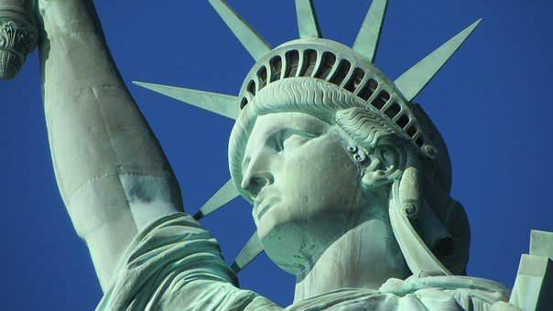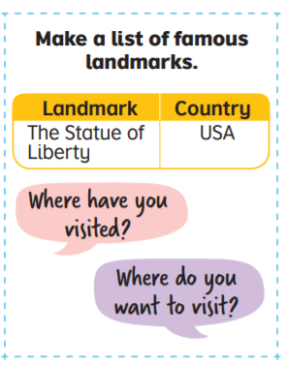

the winner!

famous landmarks as you can. The group with the most is

You have **two minutes.** In groups try to think of as many

Famous Landmarks

**X**

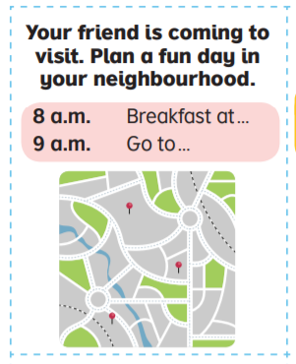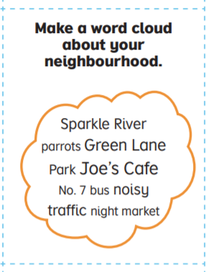

B

A

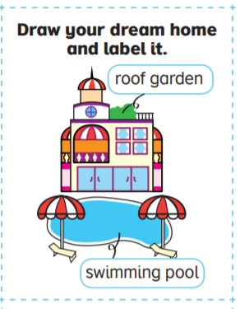

C

Choice Board

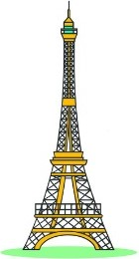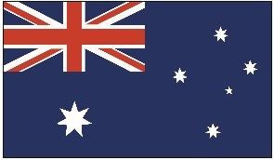

river

New York

Listen to the song. Match the names with the city where they live.

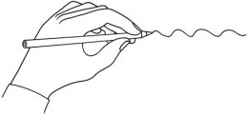

Sam

Phnom Penh

Jean Paul

London

Yem

Sarah

Paris

Natasha

Cairo

Haji

Moscow

www.britishcouncil.org/learnenglishkids

© British Council, 2017 The United Kingdom’s international organisation for educational opportunities and cultural relations. We are registered in England as a charity.



2. Match them up!

river

Eiffel Tower

city

London

listen

Big Ben

world

people

Australia

snow

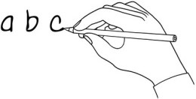

One small world

1. What’s the word?

Write the word under the pictures.

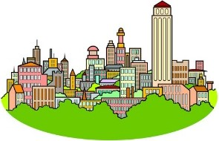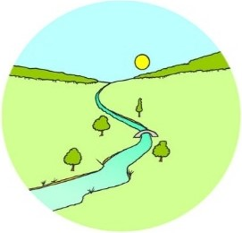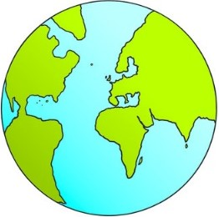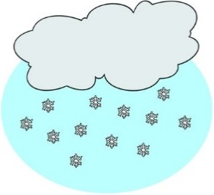

and write about it!

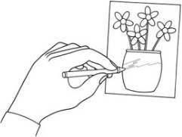

Where do you live? What interesting things can you see there? Draw a picture

4. Write and draw!



© British Council, 2017 The United Kingdom’s international organisation for educational opportunities and cultural relations. We are registered in England as a charity.

www.britishcouncil.org/learnenglishkids

..................................................................................................................................

..................................................................................................................................

..................................................................................................................................

..................................................................................................................................

..................................................................................................................................

..................................................................................................................................

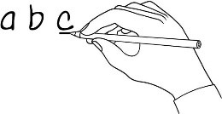

c.

Jean Paul lives in a house near the Eiffel Tower.

b.

Sam works on the banks of the Hudson lake.

a.

river

Yem lives in the village Phnom Penh.

Listen to the song. Find the mistake, underline it and write the correct word.

3. Make it right!

f.

Haji lives in the mountains of the Pharaohs.

h.

Natasha walks past the Kremlin in the winter rain.

g.

People live in Africa, in Canberra.

People live in North America, in Bogota.

e.

Sarah likes to listen to the chimes of Big Bill.

d.

**pool**

**Swimming**

**Square**

**Monument**

**Outdoor**

**Main**

**Historical**

**Theme Park**

**Museum**

exciting

**X**

www.britishcouncil.org

entertaining

historical

good for older people

good for families

busy

interesting

educational

good for shopping

peaceful

**Aquarium**

cheap

fun

expensive

relaxing

Outdoor

Ride rollercoasters

Look at paintings

Swim

What can you do at these places?

Go shopping

swimming pool

main square

historical monument

museum

theme park

.

aquarium

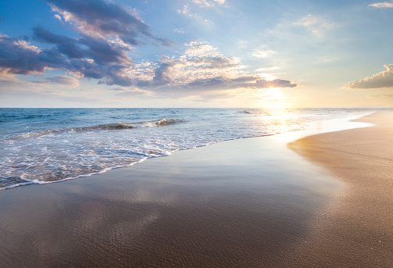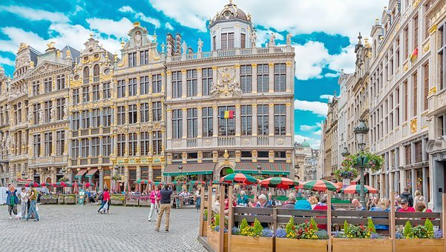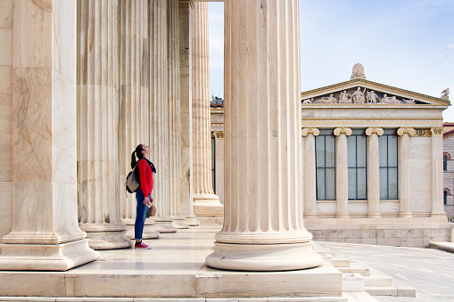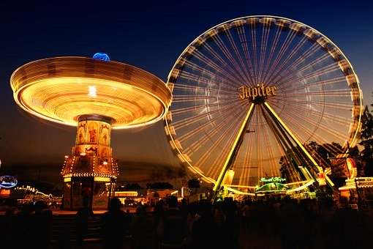

Attractions

Attractions in a neighbourhood

Look at the words below and put them into the columns to describe the place

**X**

www.britishcouncil.org

Learn about history

Learn about sea creatures

Sunbathe

Eat at restaurants

Buy souvenirs

**Entertainment**

**Name**

**Transport**

**Places to eat**

**Where we live**

Alternative final outcome task

**© British Council 2018**

Based on work by our centres worldwide

**Lower Secondary**

Name:

Plan a brochure for tourists about your own or a fictional neighbourhood.

Complete the mind map.

**What the neighbourhood is like**

Based on work by our centres worldwide

line.

**© British Council 2018**

**Welcome to**

.

.

This neighbourhood is

Name:

Create a brochure for tourists about your own or a fictional neighbourhood.

Cut the

**Where we live**

Alternative final outcome task A

lines and fold the

The main station is

**Getting around**

.

Their best dishes are

Try

Name:

**Where we live**

Alternative final outcome task A

.

You must eat at

**© British Council 2018**

Based on work by our centres worldwide

.

.

**Best attractions**

**Top places to eat**

Visit

.

.

Go to

Their best dishes are

