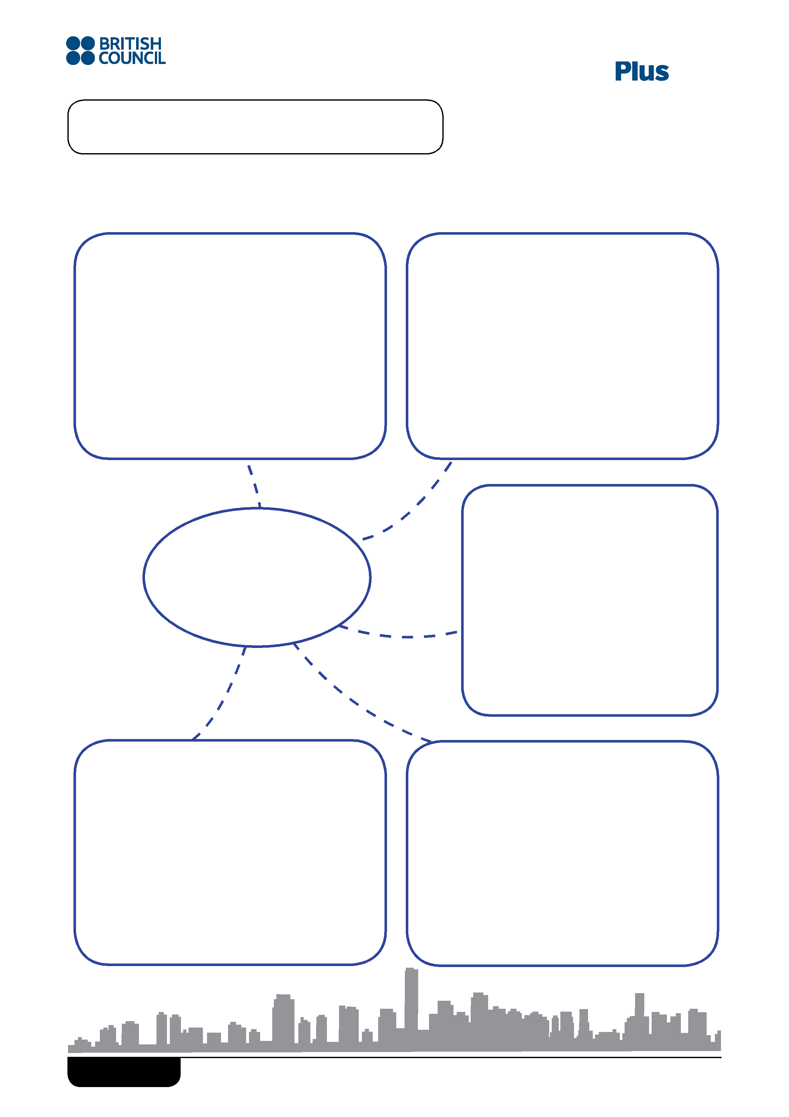
Lower Secondary
Name:
Plan a brochure for tourists about gour own or a fictional neighbourhood. Complete the mind map.
What the neighbourhood is like
Entertainment
Name
Transport
Places to eat
Where we live Alternative final outcome task © British Council 2018
Based on work by our centres worldwide

Name:

Create a brochure for tourists about your own or a fictional neighbourhood.
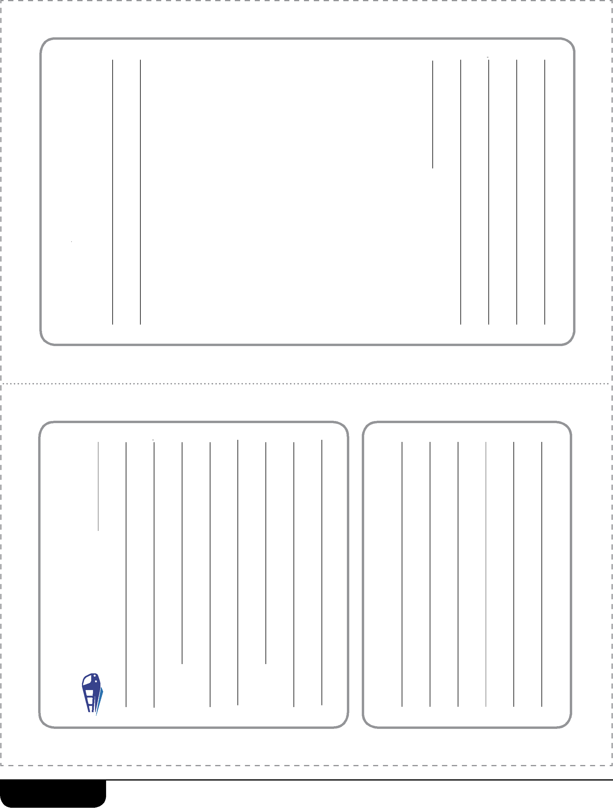
Where we live Alternative final outcome task A © British Council 2018
Based on work by our centres worldwide
Getting around The main station is
Welcome t o
.
T his neighbo u rhood is
.
Cut the lines and fold the line.

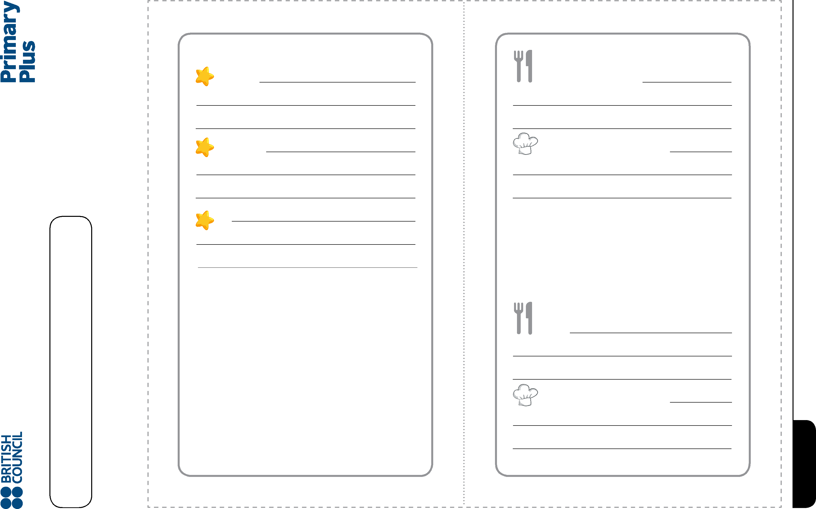
.
.
Visit
Go to
Best attractions
.
.
.
.
Their best dishes are
Try
Their best dishes are
Top places to eat
You must eat at
Where we live Alternative final outcome task A © British Council 2018
Based on work by our centres worldwide
Name:

