Antsingy leaf chameleon

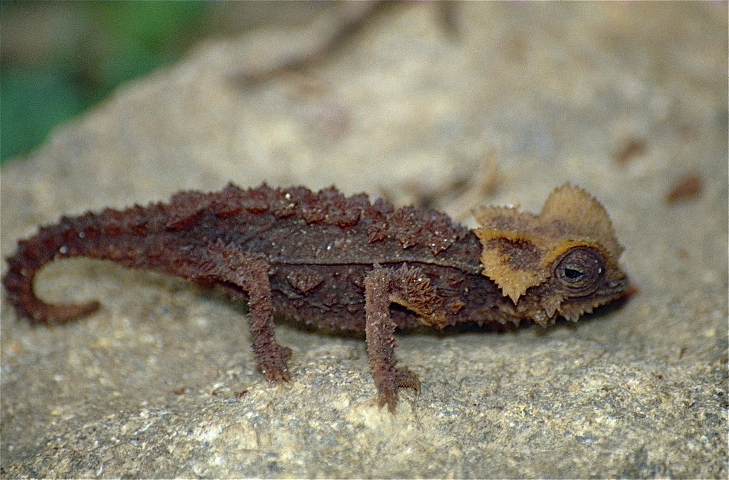

The Antsingy leaf chameleon (Brookesia perarmata) is a species of lizards in the family Chamaeleonidae. It is also called the Armoured leaf chameleon.^{[2]}
This species is endemic to Madagascar and can only be found in the dry deciduous forests of the northern area of the Tsingy de Bemaraha National Park in Madagascar's Melaky Region.^{[3]} Deforestation and destruction of habitat continue to affect their numbers despite conservation efforts.

Life
This ornate chameleon species occurs in dry, deciduous forest in Madagascar. This
Although smaller than most chameleons, The Antsingy leaf chameleon is the largest of the Brookesia (dwarf) chameleons and can grow up to eleven centimeters. This chameleon has a tail that assists them in moving amongst leaves on the forest ground. They are easily identifiable by the thorny spines on their backs and their brown coloration. Chameleons can change colors, but this chameleon has a limited colour range which doesn’t include bright colours. It feeds on small insects such as small flies and termites.

Habitat
This ornate chameleon species occurs in dry, deciduous forest in Madagascar. This chameleon lives on the forest floor among the dead leaves which it uses for camouflage and climbs up low plant branches when it's time to sleep.^{[5]} The Antsingy Leaf Chameleon lives amongst leaf litter and requires primary, relatively untouched forest habitat.

Threats
There are many threats to the Antsingy leaf chameleon's habitat but the population declined dramatically due to collection for pet trade. These leaf chameleons became a popular pet for many lizard enthusiasts in the 1980s and into the 90's before selling them as pets was banned.

Conservation[edit]
This species has been listed as Endangered (EN) by International Union for Conservation of Nature since 2011. Because of its very limited range (it only lives in Madagascar) exportation and trade of this species is illegal.

Giant golden mole
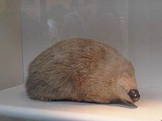
The giant golden mole (Chrysospalax trevelyani) is a small mammal found in Africa. At 23 centimetres (9.1 in) in length, it is the largest of the golden mole species. The mole has dark, glossy brown fur; the name golden comes from the Greek word for green-gold, the family Chrysochloridae name.

Characteristics
The giant golden mole has a subterranean lifestyle. It has large claws, powerful fore limbs, no external tail or ears and skin covering the eyes. It is blind and deaf. It is approximately 208-235 millimetres in length and 410-500 grams in weight. Its hair is longer and coarser than any other species of golden mole. It is nocturnal, hunting mostly at night, but also in some cool and cloudy daytime conditions.

Diet
The giant golden mole digs tunnels for hunting food and may feed on the surface hiding in the leaf litter. It eats mainly millipedes and giant earthworms, but also crickets, cockroaches, grasshoppers, worms, and snails.

Habitat
The giant golden mole lives in chambers and passages underneath forests with soft soil, deep leaf litter layers, and well-developed undergrowth.^{[1]} The giant golden mole is endemic to South Africa, mostly in a restricted area in the Eastern Cape.^{[4]}

Status
The giant golden mole was classified as Endangered (EN) in 2010 on IUCN Red List of Threatened Species. The population is decreasing due to habitat loss resulting mainly from human activities such as firewood collection, overgrazing of livestock, and cutting down trees. Moreover, the giant golden mole is preyed on by domestic dogs in that area.^{[2][3]}

Conservation
The giant golden mole currently receives little protection, and is not a main conservation target.

Red-headed vulture
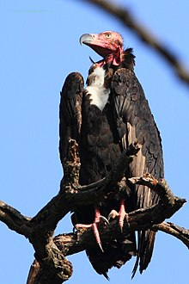

The red-headed vulture (Sarcogyps calvus), also known as the Asian king vulture, Indian black vulture or Pondicherry vulture,^{[2]} is mainly found in the Indian subcontinent, with small populations in some parts of Southeast Asia.

Description
- It is a medium-sized vulture of 76 to 86 cm in length, weighing 3.5–6.3 kg and having a wingspan of about 1.99–2.6 m. ^{[4]} It has a prominent naked head: deep-red to orange in the adult, paler red in the juvenile. It has a black body with pale grey band at the base of the flight feathers. Adult male red-headed vultures have white (or pale) eyes. Adult females have dark eyes.

Distribution and habitat[edit]
Historically there were was a large population of red-headed vultures across the Indian subcontinent, and also eastwards to south-central and south-eastern Asia, extending from India to Singapore. Today the red-headed vulture lives primarily in northern India. It is usually in open country and in cultivated and semi-desert areas. It is also found in deciduous forests and foothills and river valleys. It is usually found up to an altitude of 3000m from sea level.^{[6]}

Diet
Like other vultures, red-headed vultures eat animals that are already dead, such as deer, jackals and livestock (animals kept by farmers such as cows).

Conservation status
Main article: Indian vulture crisis
The main threat to the survival of the red-headed vulture is the use of a drug called diclofenac. Diclofenac is a medicine people give their livestock (cows, donkeys) when they fall ill. Diclofenac is extremely poisonous to vultures, so when they eat animals who have diclofenac in their system, they die. The red-headed vulture population has declined rapidly since 1990s, and has come dangerously close to extinction. Consequently, it was listed as critically endangered in th
e 2007

Kaluga (fish)

