Adapted from https://learnenglish.britishcouncil.org/skills/writing/upper-intermediate-b2/an-opinion-essay

Task 1

Scan the opinion essay and decide if you think the writer agrees or disagrees with the statement. Highlight your evidence!

Opinion Essay

Nowadays we do not need to remember anything because information is so easy to find on the internet. Do you agree?

Nowadays all the information we need is available online and because of this some people say it is not necessary to learn anything.

It is true that we can find everything we want to know as long as we have internet access. However, not everyone has a good internet connection all the time, for example in certain buildings or remote locations, so we do need to remember information. Moreover, it can take a long time to search for everything you need to know online, whereas remembering something is immediate. The human memory is a much more efficient system.

Another problem is the quality of the information online. How do we know if it is accurate or reliable? We need to think about other facts we know and remember how to compare information from different websites. Knowing (and remembering) how to find certain information will be more important than knowing the information itself.

Finally, the internet is a good resource, but it is not a substitute for our brains. If we did not remember anything, we would spend even more time on our phones and computers, which is not good for society.

In conclusion, the internet has many advantages, but it is still important to use our knowledge and memories. We need our memories to function without the internet and we also need to know how to use the internet properly.

Task 2
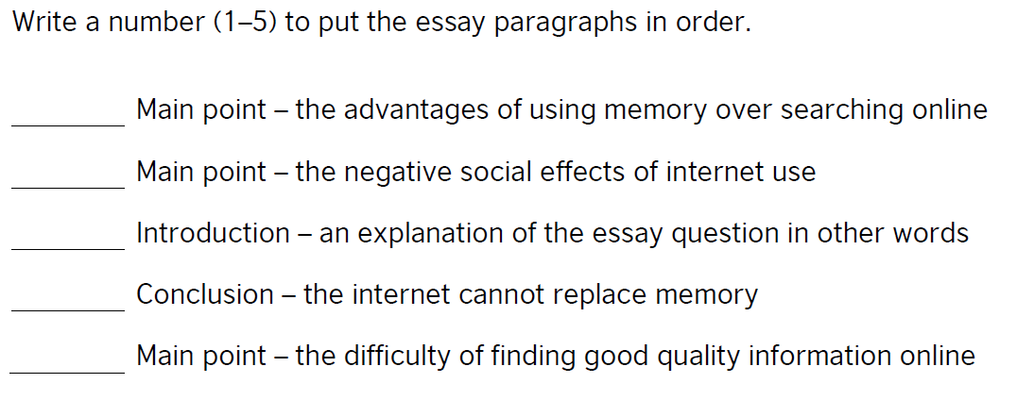

Task 3

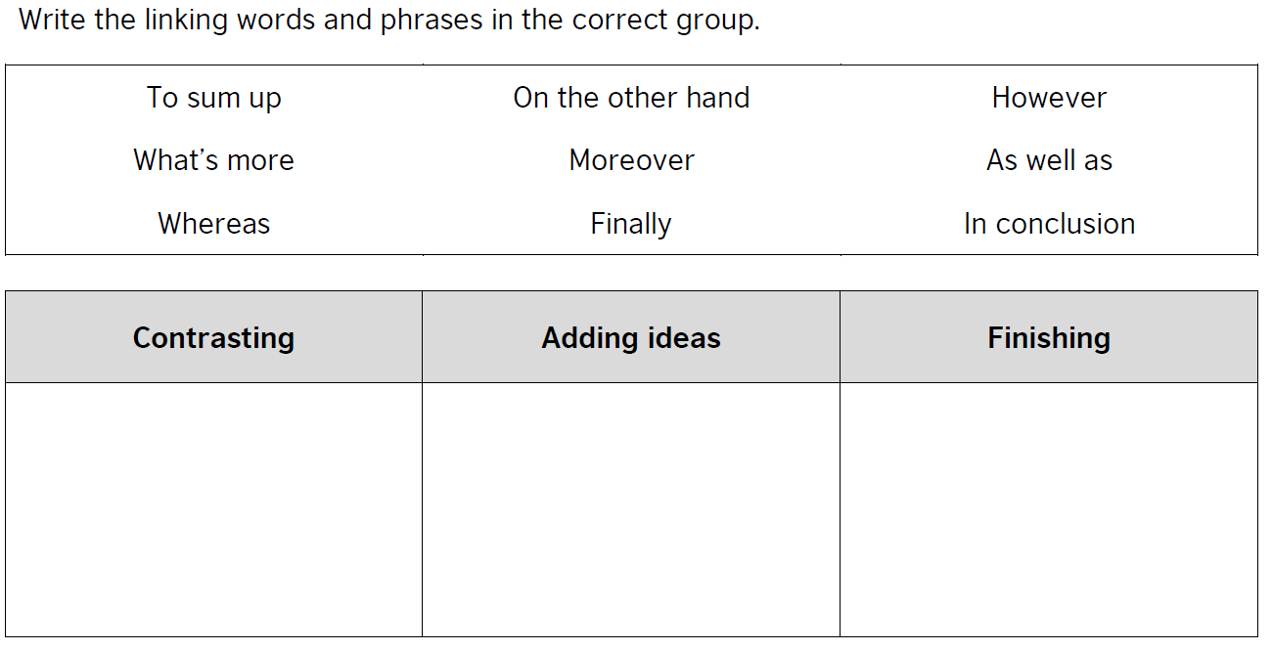

EXTENSION: can you add any more examples?

Task 4

Write your own opinion essay in answer to the question!

- Look back at your table of agree/disagree points to help you to plan your essay
- Include both sides of the argument
- Use the model essay to help you but don’t copy directly
- Organise your ideas into paragraphs
- Use linking words
- Write in a formal register
- Try to use a range of interesting language
- Re-read your work to check for mistakes

Write approximately 150-180 words

