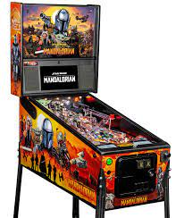
Pinball Wizard – The Who

- Read the following lyrics and with your partner try to predict some of the missing words.

Ever since I was a young boy, I've played the silver ball
From Soho down to Brighton I must have played them all
But I ain't seen nothing like him in any ___________ ______
That ____, _____ and blind kid, sure plays a mean pinball

He stands like a _____, becomes part of the machine
Feeling all the _______, always playing clean
He plays by intuition, the digit counters fall
That _____, _____ and blind kid, sure plays a mean pinball
Flippers
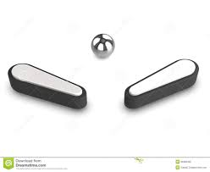
He's a pinball wizard, there has got to be a twist
A pinball wizard's got such a ______ ________
How do you think he does it? I don't know
What makes him so good?

Ain't got no distractions, can't hear no _________ and bells
Don't see no _______ a-flashing, plays by sense of smell
Always gets a replay, never seen him fall
That _____, ______ and blind kid sure plays a mean pinball

I thought I was the Bally table king
But I just handed my pinball crown to him

Even on my favourite table, he can ______my best
His _______ lead him in and he just does the rest
He's got crazy flipper _____, never seen him fall
That ______, ______ and blind kid, sure plays a mean pinball

Now listen to the song and fill the spaces.

- Finds words in the song that mean the following:

- The part of your body which joins your arm to your hand

- The ability to understand something instinctively

- Gave

- Not able to speak

- Not able to hear

- An award / prize

- Score

- Do you know anyone who’s really good at playing a game? Tell your partner.

