A Look at the image below and try to describe it to your partner, using as many of the compound adjectives as possible:

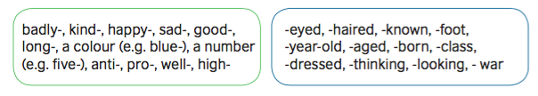

Your partner should draw as you speak.

https://digerible.com/arte-urbano-patrick-commecy-cannes-francia/
Plan what you are going to say here:

Listen to your partner and draw what you hear:

