CAE Speaking Part 3: Reaching an Agreement

The task
You are going to hear two people completing the part 3 task below:
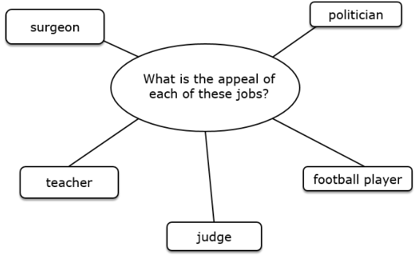
They must first discuss the question in the middle for two minutes. Then they have one more minute to decide which job should receive the highest salary.

First Listen
Cover the transcript below, listen to the audio and answer the following questions:
- Which jobs do they talk about?
- What different reasons do they give for why the jobs appeal to people?
- Which job do they decide deserves the highest salary?

Second Listen
Listen again, this time listen for different phrases and expressions for giving opinion and agreeing and disagreeing.

Third Listen
Now listen again with the transcript and try to fill the blanks.
- Tim: Errr so _____________?
- Raquel: Sure
- Tim: Let’s start with surgeon. Ummm, well __________, I think being a surgeon appeals to people probably because, __________, you’re helping people, you might be saving peoples’ lives and you’re making a big contribution to society
- Raquel: _________, yeah, ______________ but, _______________? I think that at least in our society teachers should be given more.. they should be empowered maybe more than surgeons because they really can make a change in peoples’ lives.
- Tim: Yeah I think _____________. They’re definitely very important and I could see why people would want to be a teacher, because of the way they can, you know, help people and educate people.
- Raquel: Yeah, __________________ both professions here, I think that they are very vocational, like being a surgeon or being a teacher.
- Tim: _________, yeah, yeah, ______________. Ummm what about the other ones over here? Let’s ___________ a football player, what’s ____________ that?
- Raquel: Buff I’m not really sure, I don’t think that they have to… How can I put this? Umm, I don’t really like football and I think they just, they’re earning far too much and I don’t buy the idea of like their career is too short.
- Tim: _____________, surely it’s good to do a job that’s something you love, surely if you’re a big fan of football then if you’re spending all day every day doing, you know, your favourite activity that must be good no?
- Raquel: Yeah, _______________ and that was my idea when I was talking about vocational jobs before. But still, I think it’s a bit too much, the gap between the payment is just crazy.
- Tim: Yeah __________. Well so we’ve got to… the ___________ is…
- Raquel: The ____________ is we have to choose one so…
- Tim: Yeah, which one should receive the most… the highest salary? Well I’m _________ maybe a surgeon and a teacher, _________________?
- Raquel: Well it’s true that _____________ the surgeon might save the actual physical life whereas the teacher might just contribute to our long life _______ ummm enrichment or, you know, making people grow so maybe it’s more like long-lasting.
- Tim: Well ______________ what you were saying about, yeah the contribution to society I think they’re both very important.
- Raquel: Yes, it’s really difficult to choose between these too.
- Tim: But maybe you know without the teachers, you wouldn’t have the surgeons…
- Raquel: ___________
- Tim: Who’s going to teach the surgeons? So, _____________ teacher?
- Raquel: Ok, alright.
- Tim: Ok, perfect.

The Expressions
Check your answers and then put the different expressions below into the boxes based on their meaning.
- As I see it,  - Shall I start?  - What’s your take on that?  - You know  - How can I put this?  - What do you reckon? | - Yeah I’d go along with that.  - Coming back to what you were saying about…  - I’m torn between… and…  - At the end of the day…  - Sort of/kind of | - I take your point but…  - Shall we go with…?  - Exactly/definitely  - It’s also worth bearing in mind that…  - You’ve got a point there

Starting | Giving Opinion | Agreeing | Disagreeing
Asking opinion | Adding + Referring | Fillers/time-buyers | Reaching a conclusion
Work with a partner; try to add at least one more expression to each box.

Pronunciation
Look at the expressions below, listen to the expressions and try to take notes about how they’re pronounced. Then try to reproduce them with a partner.
- Shall I start?
- What do you reckon?
- How can I put this?
- As I see it,
- Yeah, I’d go along with that.
- It’s sort of, like a pizza but different.
- Shall we go with teacher?
- Coming back to what you were saying about teachers…

Scripted Role-play
Decide who is going to be Tim and who is going to be Raquel. Use the transcript on the previous page to recreate the conversation, play close attention to the pronunciation of the expressions.

Your Turn
Find an example of a part 3 task in your textbook and complete it with your partner. See who can use the most expressions, keep count while your completing the task, the winner is the one who uses the most.

